HERA and Starlink: Overview of Project
Thea Snyder
1-28-2026
Intended and unintended radio emissions from satellites are known to interfere with radio astronomy, and due to the dramatic increase in the number of satellites orbiting the Earth, this is becoming a progressively large concern. As of December 19, 2025, there were 9,357 Starlink satellites orbiting the Earth. This amounts for around 62% of all satellites orbiting the Earth. Since SpaceX’s first launch on May 23, 2023, there has been concern for the potential impact on the astronomical community. In 2017, the U.S. Federal Communications Commission approved SpaceX’s proposal to put 12,000 satellites in orbit, but SpaceX has sent a proposal to the International Telecommunication Union requesting approval to add 30,000 more satellites to the Starlink megaconstellation. The aim of this project is to study the impact that Starlink satellites may have on 21 cm power spectrum measurements of the Epoch of Reionization (EoR) and potentially search for mitigation strategies.
Based on the results of prior studies conducted at other radio telescopes, SKA-Low (Grigg, et al, 2023, 2024, and 2025) and LOFAR (Bassa, et al, 2024), Starlink satellites have been detected in the frequency ranges of 40-88 MHz and 108-188 MHz. This study focused on the impact of Starlink satellites on the Hydrogen Epoch of Reionization Array (HERA). The range that HERA measures, 50-230 MHz, was surveyed, and the observations were correlated to when Starlink satellites had passed overhead.
The satellite orbit history was found on the website Heavens Above. The point of pass-over used was the coordinates for HERA’s location (30°43’17” S, 21°25’42” E), which should be considered as it may not be positioned exactly over the antenna array. This information was copied over to an Excel spreadsheet and then saved as a .csv file that could sent through a python program that could convert to Julian dates, passes-convert-time.py. The HERA data that was analyzed came from the H6C IDR. The calendar date that was looked at was October 14, 2022. The pass-over information, pass-over time converting python program, and the python code used to create the waterfall graphs can be found at:
https://github.com/tsnyder0/HERA-starlink
Figure One: Amplitude and Phase Waterfall Graphs in both ee and nn orientations
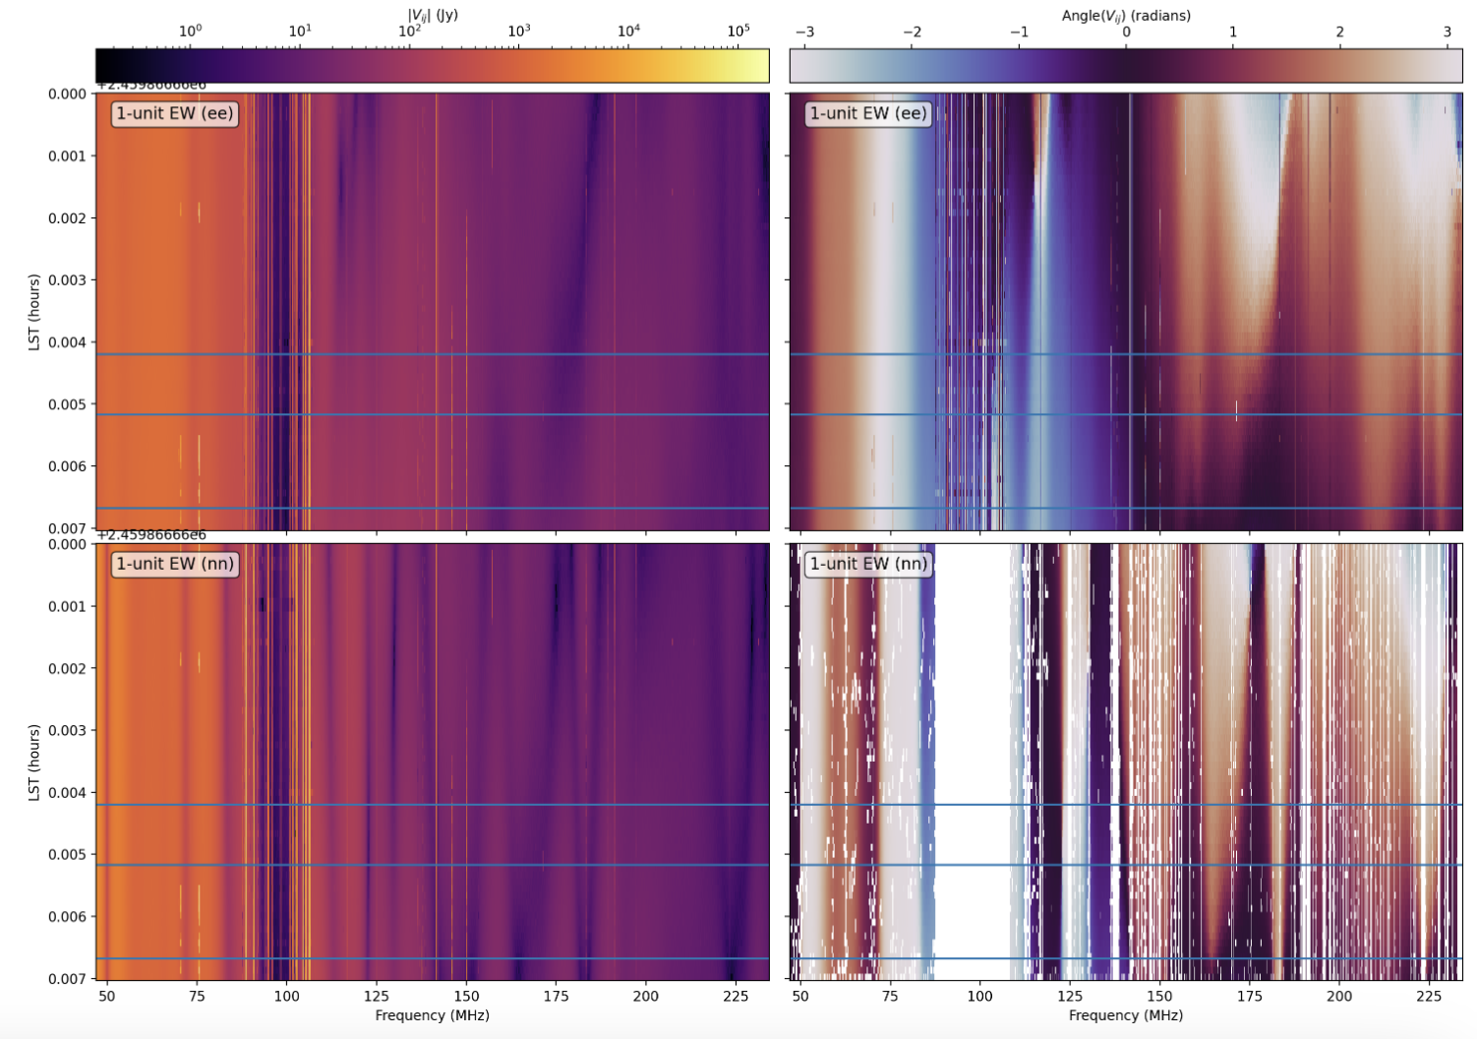
Figure One shows the amplitude and phase waterfall graphs for both ee and nn orientations. The Julian dates of the data used for these graphs ranges from 2459866.65999238 to 2459866.66703881, and the frequencies are within 46-234 MHz. The three blue lines are instances in which a Starlink satellite was at its highest point while passing over the antennas. Those Julian dates were 2459866.665173611, #.6666782405, #.664201389.
At this point, the next steps are to analyze the waterfall graphs against the highest-point pass-over information more thoroughly. Larger data sets should be used as well as examining other dates.

